BRACT’s

Vishwakarma Institute of Information Technology, Kondhwa(BK), Pune-48

Department of CSE-AIML



Project On

Smart Loan Risk Analyzer with Bank Recommendation

using Machine Learning

TY BTech CSE AIML

Year: 2024-25

Group Members:

|  |  |  |
| --- | --- | --- |
| **GrNo.** | **RollNo.** | **Name of Student** |
| 22320224 | 391079 | Divya Jabras |
| 22320202 | 391078 | Shraddha Sonawane |
| 22211519 | 391044 | Saroj Phalke |

**Guide Name: Dr. Disha Wankhede**

**2. Index**

|  |  |  |
| --- | --- | --- |
| **Serial No.** | **Topic** | **Page No.** |
| 1. | Title Page | 1 |
| 2. | Index Page | 2 |
| 3. | Abstract | 3 |
| 4. | Introduction | 4 |
| 5. | Software Requirement | 5 |
| 6. | Screen Snap Shots of Project | 6 |
| 7. | Future Aspects of Project | 7 |
| 8. | Conclusion | 8 |
| 9. | References | 9 |

# 3. Abstract

The **"Smart Loan Risk Analyzer with Bank Recommendation using Machine Learning"** project automates loan eligibility assessment and provides personalized bank recommendations with EMI calculation. It uses a trained machine learning model to evaluate user input and generate a credit risk score. Based on the user's profile and predicted risk level, the system recommends optimal banks and calculates monthly EMIs based on interest rates.

**Key Features:**

* Machine learning-based loan approval predictor.
* Creditworthiness scoring (0–100) and risk level classification.
* Personalized bank suggestions (based on risk and interest rate).
* EMI calculation and tabular comparison.
* Streamlit UI for real-time interactive predictions.

This system demonstrates how **AI/ML** can enhance the financial decision-making process for individuals while improving transparency, accessibility, and efficiency for financial institutions.

# 4. Introduction

**4.1 Background & Problem Statement**

Loan approval processes are traditionally manual, rigid, and binary (yes/no). They fail to consider individual user characteristics or explain rejection reasons. Moreover, customers lack tools to compare the best bank offers that suit their risk level and repayment ability.

**4.2 Proposed Solution**

We built a smart loan eligibility predictor using ML that:

* Predicts loan approval probability using user profile data.
* Scores the applicant (0–100) and categorizes risk as Low, Medium, or High.
* Recommends bank offers based on risk match and ROI.
* Calculates EMI for each eligible bank.

**4.3 Technologies Used**

* Python + Streamlit for UI
* Scikit-learn + XGBoost for ML modeling
* Pandas, NumPy for data manipulation
* Joblib for model persistence
* Matplotlib / Seaborn (optional visuals)

**4.4 Applications**

* Banking: Smart, fast loan assessment
* FinTech: Automated loan comparison & recommendation
* Credit analysis platforms: Risk-based lending evaluation

**5. Software Requirement**

**5.1 Libraries & Tools**

|  |  |
| --- | --- |
| Category | Tools Used |
| Programming Language | **Python 3.10+** |
| UI Framework | **Streamlit** |
| ML Frameworks | **XGBoost, scikit-learn** |
| Data Handling | **Pandas, NumPy** |
| Visualization | **Matplotlib, Seaborn** |
| Model Storage | **Joblib** |

**5.2 Hardware Requirements**

* **Processor:** Intel i5 / Ryzen 5 or above
* **RAM:** 8 GB minimum
* **Storage:** 500 GB SSD (for model training)
* **GPU:** Optional for faster training

**5.3 Software Requirements**

* **OS:** Windows/Linux
* **Python Environment:** Anaconda / venv
* **Libraries:** streamlit, xgboost, scikit-learn, pandas, joblib, imblearn

**6. Screen Snap Shots of Project**

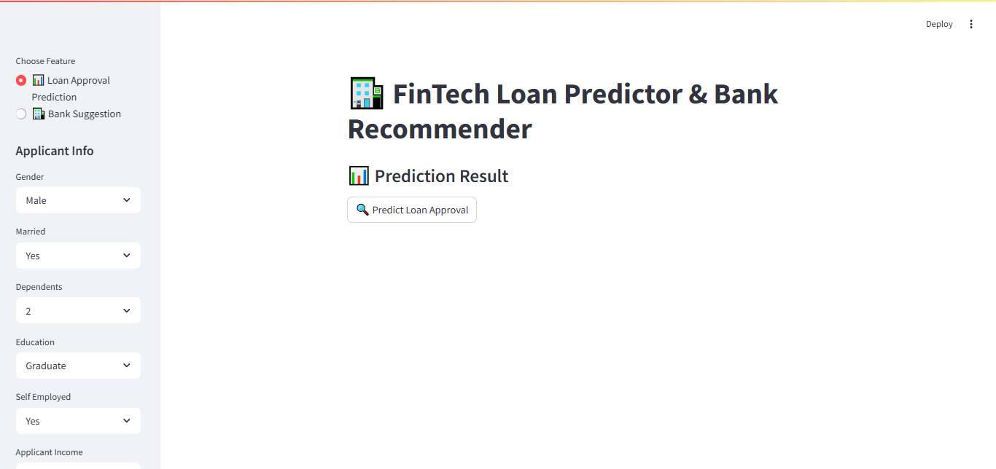

**Fig 1. User Interface**

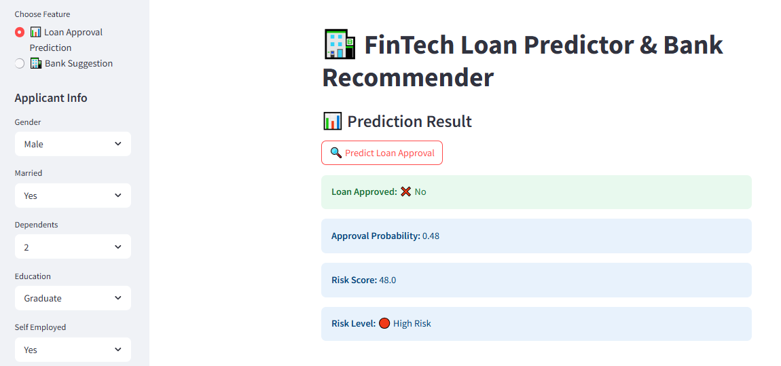

**Fig 2. Result of Loan Prediction**

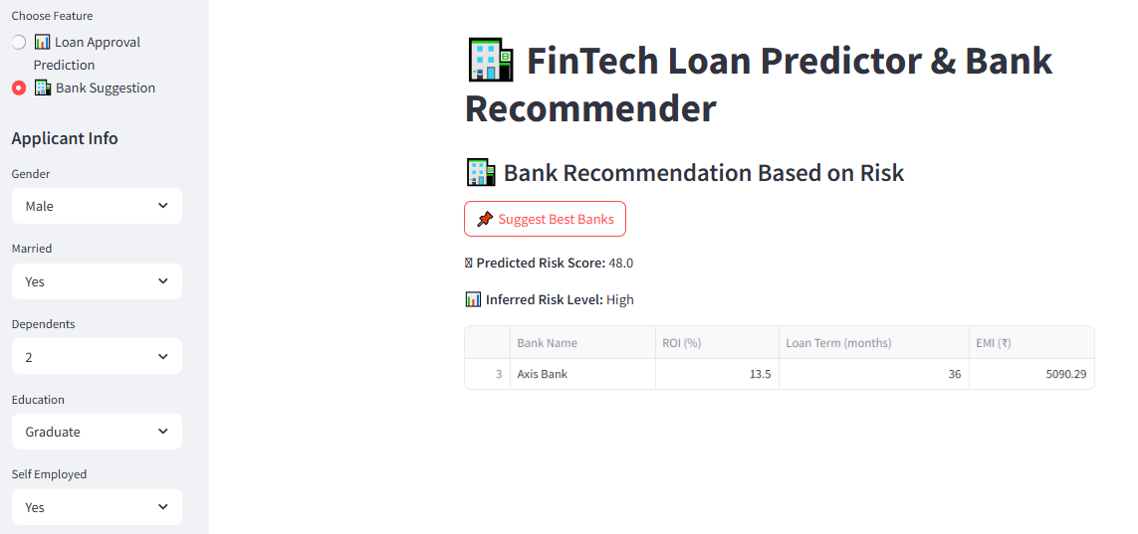

**Fig 3. Result for Bank Suggestion+**

# 7. Future Aspects of Project

API Integration with real bank offers from platforms like PaisaBazaar, BankBazaar, etc.

* 1. User Authentication with profile saving and dashboard view.
  2. Explainable AI (with SHAP values) for better reasoning behind approvals or rejections.
  3. Dynamic EMI filter based on user income and affordability.
  4. Chatbot support for finance-related queries using LLMs**.**

# 8. Conclusion

This project successfully integrates AI with financial technology to automate risk-based loan approval and bank recommendation. It provides a transparent system that not only predicts the approval but also empowers users to choose from the best offers.

The Streamlit-based UI makes it usable for demos, prototypes, and real-world deployment. Future improvements like bank API integration and affordability intelligence will make it more robust and adaptive.

**9. References**

* 1. [*https://xgboost.readthedocs.io/*](https://xgboost.readthedocs.io/)
  2. [*https://streamlit.io/*](https://streamlit.io/)
  3. [*https://scikit-learn.org/*](https://scikit-learn.org/)
  4. *https://www.kaggle.com/datasets/ninzaami/loan-predication*
  5. [*https://en.wikipedia.org/wiki/EMI_(finance)*](https://en.wikipedia.org/wiki/EMI_(finance))